City of Gelsenkirchen, Germany
  - In the middle of the Ruhr metropolis

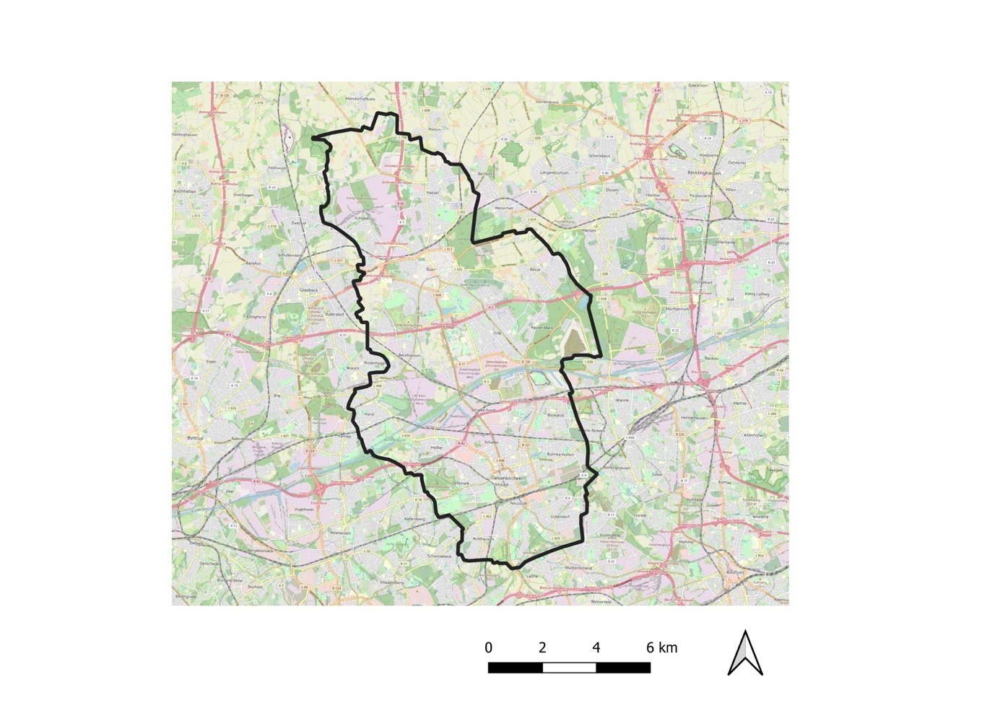
Gelsenkirchen is located in North Rhine-Westphalia (NRW) in the middle of the largest polycentric conurbation in Germany, the Ruhr metropolis (Ruhr area) with over 5 million inhabitants and has 264,710 inhabitants (September 25, 2020). Around 31% of the people living in Gelsenkirchen are German citizens with a migration background and / or foreign citizens.
As a result of decades of economic and social change (Gelsenkirchen was previously characterized by the coal and steel industry – ‘City of Thousand Fires’), the city now has renovated and rebuilt numerous former mining sites (coal mines, coking plants, steel works) and given them new uses. Some of these fallow areas were converted into smaller inner-city parks or integrated into urban and regional green and forest areas ("Emscher Landscape Park" of the Ruhr Metropolis) and fulfil functions as "urban wilderness areas", "nature discovery areas", "places for extracurricular learning"; ("Biomass Park, Rheinelbe Forest Station") and "Green Laboratories" with a focus on nature experience, community gardening, urban forest and (environmental) education.
State of the Urban Forest
The Ruhr area is shaped and reshaped in many parts by anthropogenic influences.
Therefore, depending on their origin, the forest images range from old forest relics with remnants of potentially natural vegetation to planted forests to pioneer forests on post-industrial areas that have emerged from succession.
They form a significant part of the green infrastructure in the Ruhr area. The socio-economic and ecological services of the forest represent an irreplaceable social value.
Here, regulatory ecosystem services (CO2 sink function, fresh air formation, fine dust filtering, flood protection, cooling effect) of the forests are just as important as their function as an important recreational area. At the same time, the biodiversity of these forests is impaired by heavy pollution, eutrophication and a high level of disturbance, which contributes to a certain homogenization of flora and fauna and the promotion of neobiota.
Forest in the territory of the Ruhr Regional Forestry Office: 70,000 ha (total area: 340,000 ha); Share of forest cover: 21% (NRW 27%); Forest area per inhabitant: 143 m² (NRW 508 m²); Distribution of ownership: 67% private forest, 32% communal / state forest
In Gelsenkirchen there are around 1,430 hectares of land with a forest-like character (total area of the city: 10,494 hectares) - of these are 100 hectares of forest in parks and 270 hectares of industrial forest and forest areas on slagheaps.
The industrial nature or the industrial forest is a specialty in the Ruhr area. The term industrial nature refers to nature that has developed independently on the areas of the former mining industry, on derelict railway tracks, train stations and commercial areas. Industrial nature is an expression of the decline in industry and at the same time a signpost for new open spaces. As a result, a ‘new type of ecosystem’ has established itself which did not exist in pre-industrial nature.
Large and structurally rich industrial wastelands are hot spots for biodiversity, as they are often home to many endangered animal and plant species. In addition to the ecological networking of living spaces, they make a significant contribution to urban biodiversity and are at the same time places for relaxation, nature experience and environmental education.
In the course of the succession, the former open land biotopes develop into forest in the long term.
As the examples of the Hugo Green Laboratory and the Rheinelbe Forest Laboratory show, the links and synergies to the subject areas of ‘history’, ‘social’ and ‘environmental education’ are very pronounced.
‘Grünlabor Biomassepark Hugo’ - a "green laboratory" and a "learning place for education for sustainable development" - and its neighboring city quarters. (Duration: since 2016)
https://www.gelsenkirchen.de/de/Infektur/Umwelt/Kli ma / Klimaschutz / Erneuerbare_Energien / Biomassepark_Hugo.aspx. With innovative forest types and forest combinations, answers to climate change and the energy transition in the biomass park are sought, taking into account social and nature conservation aspects. A concept was developed here with many actors in which the experience of nature, joint action and (environmental) education find a suitable place. In this way a new city park could be won, which incurs lower maintenance costs than usual in terms of maintenance and at the same time develops new qualities through civic engagement.
‘Industrial forest Ruhr area (Industriewald Ruhrgebiet)" - Learning place for education for sustainable development" and succession research – forest of the future. (Duration: since 1996)
https://www.wald-und-holz.nrw.de/ueber-uns/einrichtungen/regionalforstaemter/ruhrgebiet/industriewald-ruhrgebiet
The aim of the project is to maintain the industrial wasteland of the Emscher Landscape Park through natural development processes and to make it accessible to people in a targeted manner as nature experience, nature experience spaces, places of environmental education and recreation close to home. The result is a completely new, authentic type of open space in the Ruhr area, which combines aspects of the past as a production location with those of the present (fallow land) and future (forest). The developments are accompanied by natural and social sciences. The change process on the industrial wasteland is also taken up in landscape art, accentuated by design measures and taken into account in a special way.
Due to the last three dry years (2018-2020), the trees in the Ruhr area suffer from the consequences of the drought. In addition, there are further impairments from the storms ELA in 2014 (June) and Friederike 2018 (January), the ash shoot death, the soot bark disease of the maple, the beech complex disease as well as the small beech bark beetle and the oak processionary moth, which led to a significant loss of vitality of the trees.
Governance, planning and policy landscape
The Ruhr Regional Association (RVR) is the amalgamation of eleven big cities and four districts in the Ruhr Metropolis. The RVR is currently preparing a regional plan for the entire Ruhr Metropolis. It is not only responsible for state regional planning in the region, but is also responsible for important infrastructure projects such as the Route of Industrial Culture and the Emscher Landscape Park (ELP).
In Germany, municipal land-use planning is located below regional planning; it covers the area of a municipality in the form of land use planning. As the lowest level of spatial planning, there is the binding land-use planning in the form of the development plan at the district and neighbourhood level.
The city of Gelsenkirchen has had a legally binding “landscape plan” since 2000. The landscape plan implements the goals and measures of nature conservation in the area of the city of Gelsenkirchen. It specifies and supplements the nature conservation content of the regional plan as a landscape framework plan. The landscape plan records and evaluates the natural balance in the planning area, develops goals and measures for the sustainable protection and development of the protected assets. The protected assets include the plants, animals and biotopes to be preserved in their biological diversity, as well as the landscape. Soil, water, air and climate should be protected as far as possible through measures of nature conservation and landscape management.
The Emscher Landscape Park (ELP) is a regional cooperation project in the northern Ruhr area to create the world's largest connected park system (450 km²). Due to the industrial and montane past of the region, the natural landscape is heavily populated, changed many times and structured like a mosaic. The aim of the landscape park is to create a new type of park that combines different open spaces: Preserved pre-industrial cultural landscape, areas of the regional green corridors that have been created since 1920, industrial landscape and post-industrial landscape. The more recent development of the ELP is documented in the ELP 2010 master plan, which has been drawn up by the 20 participating cities and regional institutions since 2002. It defines the area of the park and names the main themes of development (New Emschertal, ecology, infrastructure, culture, urban agriculture and forestry, development and vegetation management).
Participation citizen science
In order to meet the major global and local challenges, long-term strategies based on the principles of sustainable development are required.
In recent years, Gelsenkirchen's strategy has focused on prevention, education and participation as well as the idea of "Learning City" - the combination of integrative, equal opportunity and good education with ‘Education for Sustainable Development (ESD)’. The city of Gelsenkirchen has joined the United Nations' Agenda 2030. In 2016 the City Council - as the first of a German municipality - unanimously passed the Agenda 2030 resolution: ‘Shaping sustainability at the municipal level’. The city of Gelsenkirchen has received several awards for this.
Gelsenkirchen has been working with the dynamic ‘coexistence integration concept’ since 2015, which is constantly being further developed as required in the participatory process with citizens. Accordingly, for the multi-ethnic city of Gelsenkirchen, actively shaping integration work and living together is a self-binding, permanent and future-proof task. New challenges arise, particularly in light of current backgrounds such as flight, immigration, tendencies towards radicalization, etc. Encounters at eye level and mutual respect are of particular relevance.
In the competition entry ‘City of the Future 2030+ - Learning City’, Gelsenkirchen also focuses on education and participation. In addition to the concept of future education, research into Citizen Science 2.0, a further development of the well-known Citizen Science concept, is central to the research project.
Urban society, science, administration and business work together on an equal footing on the conception and implementation of concrete measures. This learning by doing process researches what is needed to enable work on equal terms at the interface between science and practice.
Socio-economic trends
As a former centre of the coal, iron and steel industry with almost 400,000 inhabitants, 14 mines and the location of the steel, glass and textile industry, the city recorded a population decline of around 150,000 in the 1970s with the decline of the mining industry.
At the same time, efforts were made to find new uses for the industrial and commercial sites which had fallen into disuse as a result of structural change. The International Building Exhibition (IBA) and the 1997 Federal Horticultural Show (BUGA 97) were important impulses for a fundamental change of direction - economically, ecologically and socially.
The course was set for a move away from large industrial structures towards smaller and more flexible companies, company start-ups were promoted, as was the linking of R&D (research and development) with the economy. In the course of a changed ecological awareness, Gelsenkirchen became a ‘solar city’, green spaces, parks and forests were created at former mining and steel sites, regional green corridors were created with regional cooperation projects, and the network of cycle paths was expanded on former railway lines.
Major challenges & knowledge gaps
- Strategic conflicts in relation to land use (green areas vs. commercial and residential areas)
- UFNBS vs. economic forest use
- The last green island locations in city districts / quarters are often built over as part of the so-called ‘densification’ and thus withdrawn from green use for people. The use of these open spaces for construction purposes (especially with existing tree and forest structures) results in compensation obligations such as replacement afforestation, for which available areas must also be found.
- Nature-based solutions are not yet in the consciousness of politics and administration; usually technical solutions are the focus.
- The funds made available are not sufficient to guarantee sustainable financing of the life cycle costs for the maintenance / upkeep of green infrastructure and UFNBS in times of climate change. Recommendations for action for comparable cost optimization are required.
- The monetary profit generated by UFNBS measures in the long term or the benefits from ecosystem services (society, health, environment, economy) are not sufficiently qualified and quantified.
- Although several best practice examples already exist in Gelsenkirchen: A rollout of measures of education on UFNBS is necessary.

