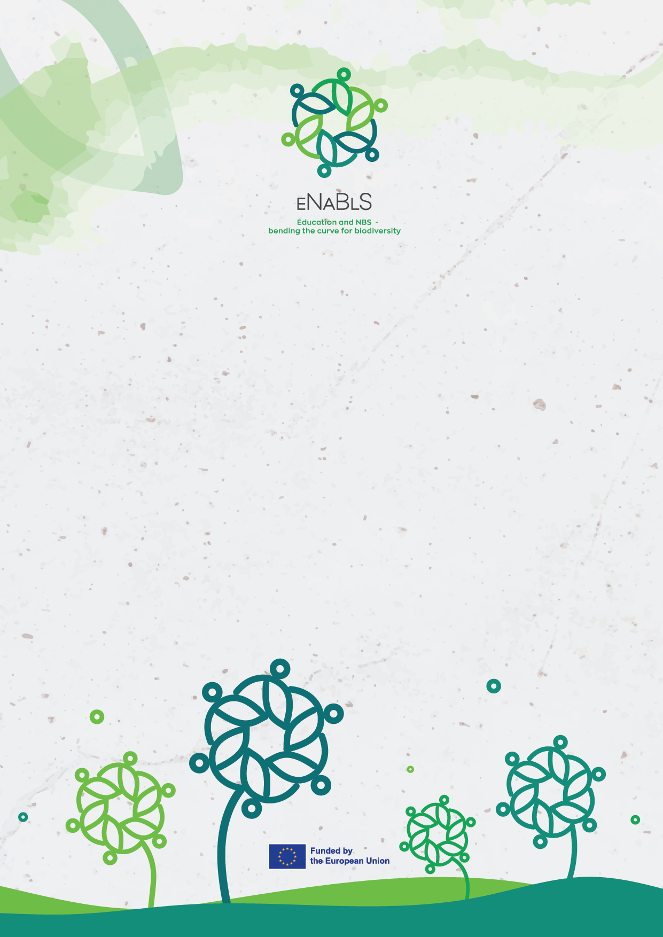

City of Overstream – role-playing simulation in NBS development
Teacher guide

Publication Information
Title | City of Overstream – role-playing simulation in NBS development, Teacher guide
Authors | Oskari Ylikoski - University of Eastern Finland  Elina Oksanen - University of Eastern Finland  Tiina Ynnilä - University of Eastern Finland  Linda Nousiainen- University of Eastern Finland
Brief summary | City of Overstream is a role-playing simulation about dialogue in Nature-Based Solutions planning. It is developed for Higher Education and students who already have at least some understanding of Nature-Based Solutions. It provides students with experiences in negotiation and discussion related to NBS development.
Publication date | 01/07/2026
Edition | 1st
Publisher | University of Eastern Finland
eNaBlS Work Package | WP2 – STRUCTURING: Providing support to Living Labs throughout the eNaBlS lifetime



© 2026 by eNaBlS consortium is licensed
under CC-BY-SA 4.0. To view a copy of this license, visit
https://creativecommons.org/licenses/by-nc/4.0.
Views and opinions expressed are those of the author(s) only and do not necessarily reflect those of the European Union or the European Research Executive Agency (REA). Neither the European Union nor the granting authority can be held responsible for them.

City of Overstram – teachers guide
City of Overstream is a role-playing simulation about dialogue in Nature-Based Solutions planning. This simulation was created by educators in University of Eastern Finland as part of EU Horizon project eNaBlS - Education and Nature-Based Solutions: enable society to bend the curve for biodiversity.

What is the role-play for?
This role-play is for students to experiment with dialogue situations related to Nature-Based Solutions (NBS). As stakeholder involvement is critical part of NBS development, it is important to simulate these situations with learners in addition to teaching theoretical knowledge about how NBS work. With stakeholders from different backgrounds, there is possibility for conflict, but as NBS are meant to be solutions where humans and more than humans work together, this simulation focuses on dialogue and finding common ground. In this role-play there is no one correct result and students should not be seen as winners or losers based on the outcome.
Gamification can provide shared “learn by doing” experiences and promote systems thinking (Dieleman & Huisingh 2006), which are all essential elements of NBS development. In this simulation aim is for students to gain experience and learning in NBS and negotiating and discussions related to it. Students will learn from different viewpoints, learn to understand these and how these may show as strategies in negotiation. Roleplaying is emergent in nature, which helps students empathize with different viewpoints and therefore learn from one’s emotions as well.
As NBS this simulation is also designed to be a living system. It is student focused and all events will be different based on students, time and space. Materials given are only meant to set the stage and context, but students and their interpretation of said materials decide where the simulated discussions will lead them. The role-play is designed to leave space for imagination and creative thinking. Each event should also modify the materials based on teachers’ notes during discussions and feedback from students.
This role-play can be played either in virtual or face to face format.
Learning objectives:
- Identify different stakeholder perspectives and their effects on urban NBS development and negotiating.
- Analyze trade-offs between biodiversity, social benefits, costs, and political feasibility.
- Practice dialogue, negotiation, and strategizing.
- Reflect on how values and interests influence planning decisions.


Figure 1: Picture from the material

What is teacher’s role?
In City of Overstream simulation teachers’ main job is to facilitate learning. This includes good preparations of materials and students, so that during the simulation students would be able to focus on immersing themselves in the given materials, their role and scenario. During the simulation, teacher’s role is to observe and take notes, and the idea is that the role-play develops freely without intervention. These will be used after the simulation to debrief with students and to develop materials further. The debrief section should be led by the teacher.
Teacher will provide students with materials and explain the scenario. They will divide them into roles and instruct how the two different discussion phases will unfold. We recommend following preparations and instructions in this guide, but as teachers know their student group best, these can be modified to group’s needs. And while simulation and the discussions are student based, support for city council group should be provided. Teachers should ensure that students acting as city councilors understand their responsibility to facilitate discussion and encourage participation from all stakeholder groups.

Preparations
Teacher themselves should go over the materials carefully, starting from this guide, so that they can react when needed to different kind of situations during the simulation. This will also help them to lead debrief section at the end, where they can ask if certain scenarios came up in discussions.
We recommend dividing students into their role groups prior to the event. This allows teacher the opportunity to provide materials to them beforehand. This saves time during the actual discussion event. To this phase where students individually get familiar with the materials, instructions should be minimal, so that students are allowed space to themselves find relevant information to their role and build individual understandings of their roles. Students should receive material packages that include all common pages (front page, suggestions, data sheet and Overstream post) and one role page (role pages are color coded).
For the actual event, appropriate space for discussion groups should be reserved, if in person two different groups should not be placed too close to each other. Also, equipment for making notes should be reserved.

How to run

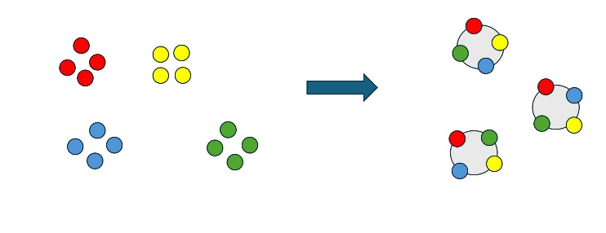
Timetable for 90 minute event:
- Instructions 10min
- Role discussions 30min
- Negotiation discussions 30min
- Debrief 20min.
Figure 2: In the event students will first discuss in role groups and later in negotiation groups.

In the event there will be two different discussion parts (Figure 2). First the students who have the same role will discuss about the materials and their role together (role discussions). In the second discussion the actual simulation and negation will happen (negation discussion). At the start of the event instructions, scenario and time flow should be explained (10min), even if students are familiar with them, and at the end of the event there should be enough time for debriefing the discussions and experiences.
In the role discussions (30min) students with the same role are meant to help each other to strategize for the negations. Teachers should use their own judgment to decide if all students with the same role are in one group or if there should be multiple groups. Group size should be one where students have enough space to present their own views and interceptions of their role, but on the other hand enough support to strategize and find relevant information. We suggest group sizes between 3-5.
After students have strategized together in their role groups, they are divided into new groups for negotiation discussion (30min). In these groups the actual simulation will happen. These discussions will be facilitated and led by students who have the city council role. They will also decide how the final decision will be made, and this should be discussed in the role discussion. Different groups, however, can use different decision making processes. Teachers’ role is to observe the discussions, take notes and make sure that timetable will be followed. At the end of the discussion students are instructed to stay in these groups for the debrief phase.

After the simulation
After the simulation teacher will lead the debrief phase (20min). They will present questions to students, which can first be discussed in the small groups and then with the whole group. Students should be encouraged to evaluate proposed NBS based on how well they address the city's identified challenges: increasing flood risk, scarcity of urban greenery, and growth pressure on surrounding natural environments. Questions which should be discussed are:
- How was the decision made?
- Which stakeholder groups that were present are the happiest with the decision?
- What trade-offs were required to reach the final decision?
- Which challenges that the city is facing are best addressed with chosen solution/solutions?
- Who benefits most from the chosen solution, and who benefits least? Think of citizens as whole, not just stakeholders present.
Teachers are also welcome to add questions to this list and use collected notes to lead the debrief. At the end of debrief there should also be time for students to give feedback about the role-play, materials and their experience

References
Dieleman H, Huisingh D. (2006). Games by which to learn and teach about sustainable development: exploring the relevance of games and experiential learning for sustainability. Journal of Cleaner Production, 14(9–11), 837–856. DOI: 10.1016/j.jclepro.2005.11.031

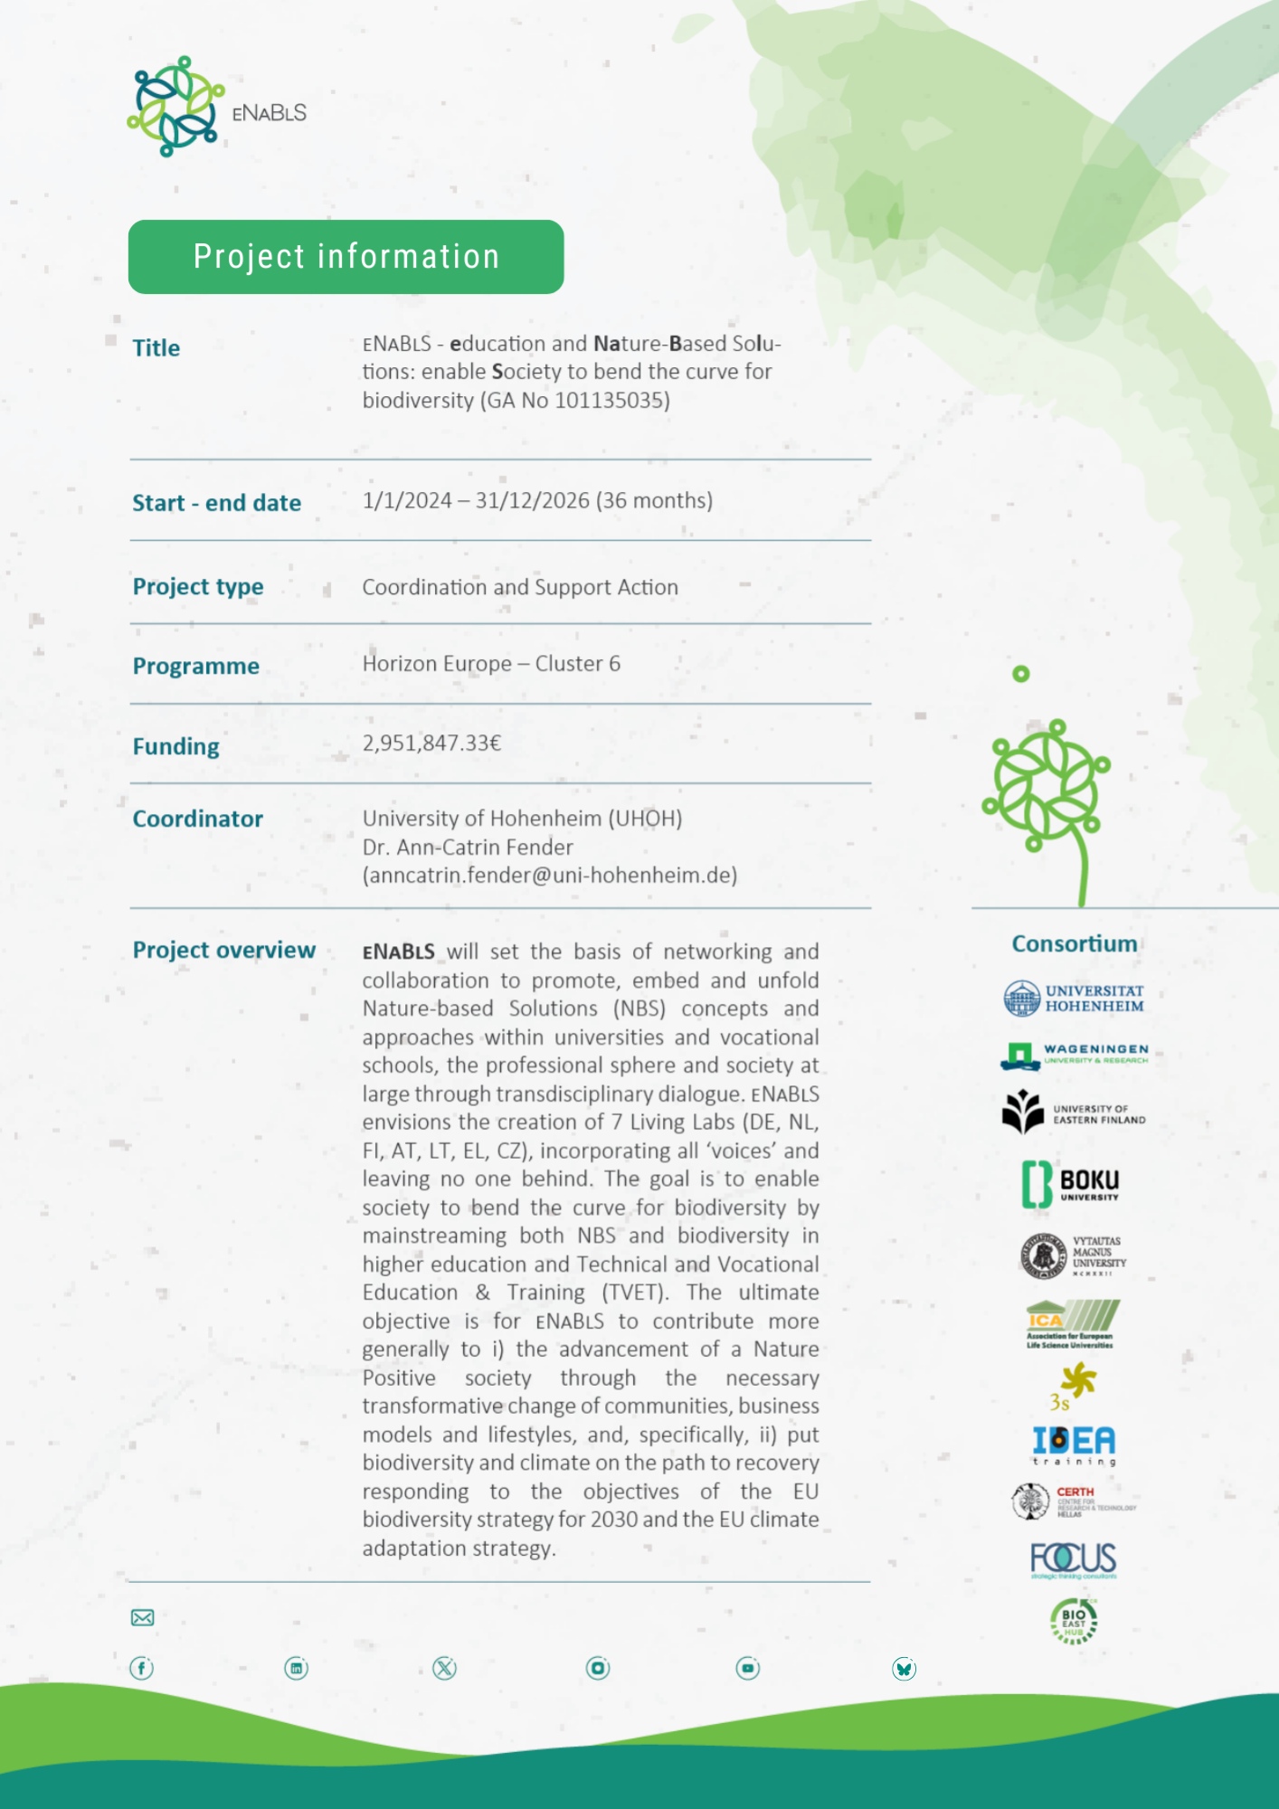
www.enabls.eu

www.enabls.eu

www.enabls.eu

www.enabls.eu

www.enabls.eu

www.enabls.eu

www.enabls.eu

www.enabls.eu

info@enabls.euwww.enabls.eu

www.enabls.eu

www.enabls.eu

www.enabls.eu

www.enabls.eu

www.enabls.eu

www.enabls.eu

www.enabls.eu

/enabls-eu

/enabls-eu

/enabls-eu

/enabls-eu

/enabls-eu

/enabls-eu

/enabls-eu

/enabls-eu

/enabls.eu/enabls-eu

/enabls-eu

/enabls-eu

/enabls-eu

/enabls-eu

/enabls-eu

/enabls-eu

/enabls-eu
@eNaBlS_eu

@eNaBlS_eu

@eNaBlS_eu

@eNaBlS_eu

@eNaBlS_eu

@eNaBlS_eu

@eNaBlS_eu

@eNaBlS_eu

/enabls-eu@eNaBlS_eu

@eNaBlS_eu

@eNaBlS_eu

@eNaBlS_eu

@eNaBlS_eu

@eNaBlS_eu

@eNaBlS_eu

@eNaBlS_eu
@eNaBlS_eu

@eNaBlS_eu

@eNaBlS_eu

@eNaBlS_eu

@eNaBlS_eu

@eNaBlS_eu

@eNaBlS_eu

@eNaBlS_eu

@eNaBlS_eu@eNaBlS_eu

@eNaBlS_eu

@eNaBlS_eu

@eNaBlS_eu

@eNaBlS_eu

@eNaBlS_eu

@eNaBlS_eu

@eNaBlS_eu
info@enabls.eu

info@enabls.eu

info@enabls.eu

info@enabls.eu

info@enabls.eu

info@enabls.eu

info@enabls.eu

info@enabls.eu

@eNaBlS-euinfo@enabls.eu

info@enabls.eu

info@enabls.eu

info@enabls.eu

info@enabls.eu

info@enabls.eu

info@enabls.eu

info@enabls.eu
@eNaBlS-eu

@eNaBlS-eu

@eNaBlS-eu

@eNaBlS-eu

@eNaBlS-eu

@eNaBlS-eu

@eNaBlS-eu

@eNaBlS-eu

@eNaBlS_eu@eNaBlS-eu

@eNaBlS-eu

@eNaBlS-eu

@eNaBlS-eu

@eNaBlS-eu

@eNaBlS-eu

@eNaBlS-eu

@eNaBlS-eu
/enabls.eu

/enabls-eu

/enabls-eu

/enabls.eu

/enabls-eu

/enabls-eu

/enabls-eu

/enabls.eu

/enabls-eu

/enabls-eu

/enabls.eu

/enabls-eu

/enabls-eu

/enabls-eu
@enabls-eu.bsky.social

@eNaBlS-eu

@eNaBlS-eu

@eNaBlS-eu

@eNaBlS-eu

@eNaBlS-eu

@eNaBlS-eu

@eNaBlS-eu

@eNaBlS_eu@eNaBlS-eu

@eNaBlS-eu

@eNaBlS-eu

@eNaBlS-eu

@eNaBlS-eu

@eNaBlS-eu

@eNaBlS-eu

@eNaBlS-eu
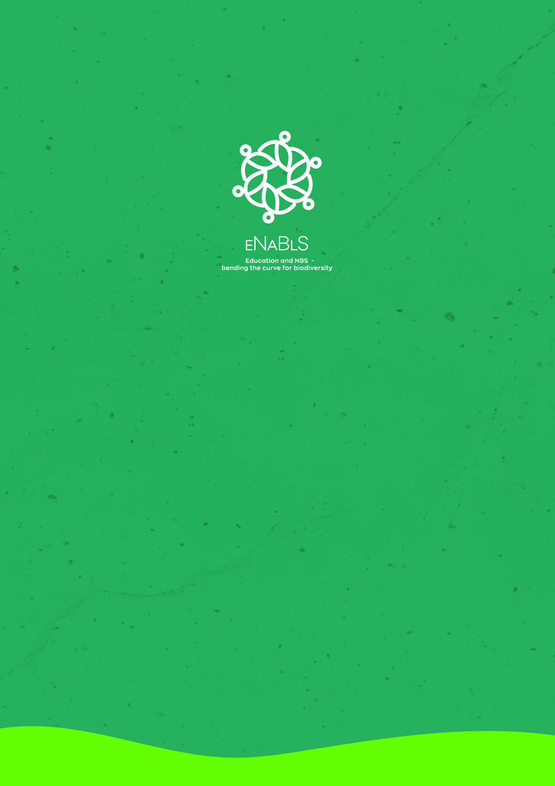
www.enabls.eu

